Dispense Method Analysis Report
Generated: 2026-03-10 15:21

1. Feature Selection

Selected Features
wh_name, is_compound, unit_of_measure, level_3, is_rx, product_type, level_2

Chi-Square Scores
The chi-square test measures the strength of association between each candidate feature and dispense_method. It tests the null hypothesis that the feature and target are independent. A higher chi-square value indicates stronger association; a low p-value (typically < 0.05) means we reject independence and conclude the feature is useful for predicting dispense method. Chi-square is well-suited for categorical variables and helps identify which product attributes (e.g., product_type, unit_of_measure) are most predictive of how a product will be dispensed.
feature | chi2 | p_value
wh_name | 226546.7928042959 | 0.0
is_compound | 198221.1080755911 | 0.0
unit_of_measure | 109747.43040651236 | 0.0
level_3 | 62331.864977227466 | 0.0
is_rx | 60808.00178986044 | 0.0
product_type | 22500.613971510636 | 0.0
level_2 | 12858.524840692986 | 0.0

Mutual Information Scores
Mutual information (MI) measures how much knowing the value of a feature reduces uncertainty about dispense_method. Unlike chi-square, MI captures non-linear relationships and does not assume a specific distribution. A higher MI score means the feature provides more information about the target. MI is useful for ranking features when building prediction models because it identifies which attributes (e.g., level_3, product_type) best reduce uncertainty about whether a product will be dispensed via automation, manual, or mixture. Features with high MI are strong candidates for the prediction model.
feature | mutual_info
level_3 | 0.6832885050486769
product_type | 0.527169706069367
unit_of_measure | 0.384349169265626
wh_name | 0.3703865000061093
is_rx | 0.2652712927621079
is_compound | 0.2552489493177118
level_2 | 0.2540616197047373

Feature Selection Visualizations

Dispense Overview
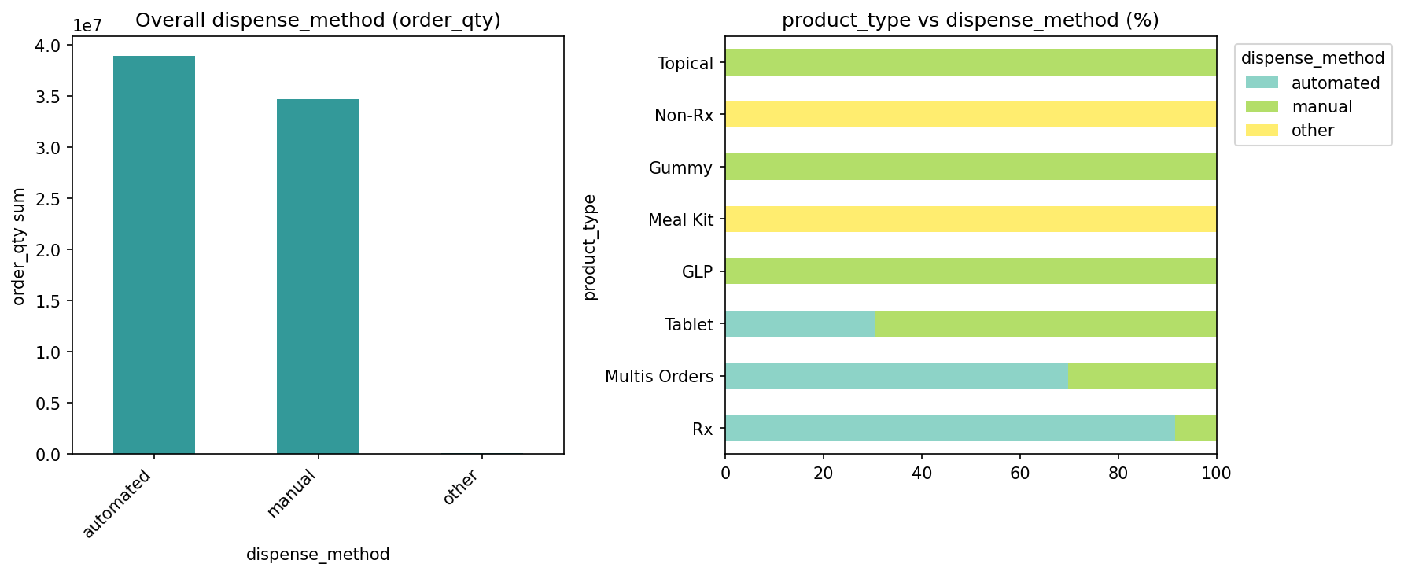

Feature Distributions
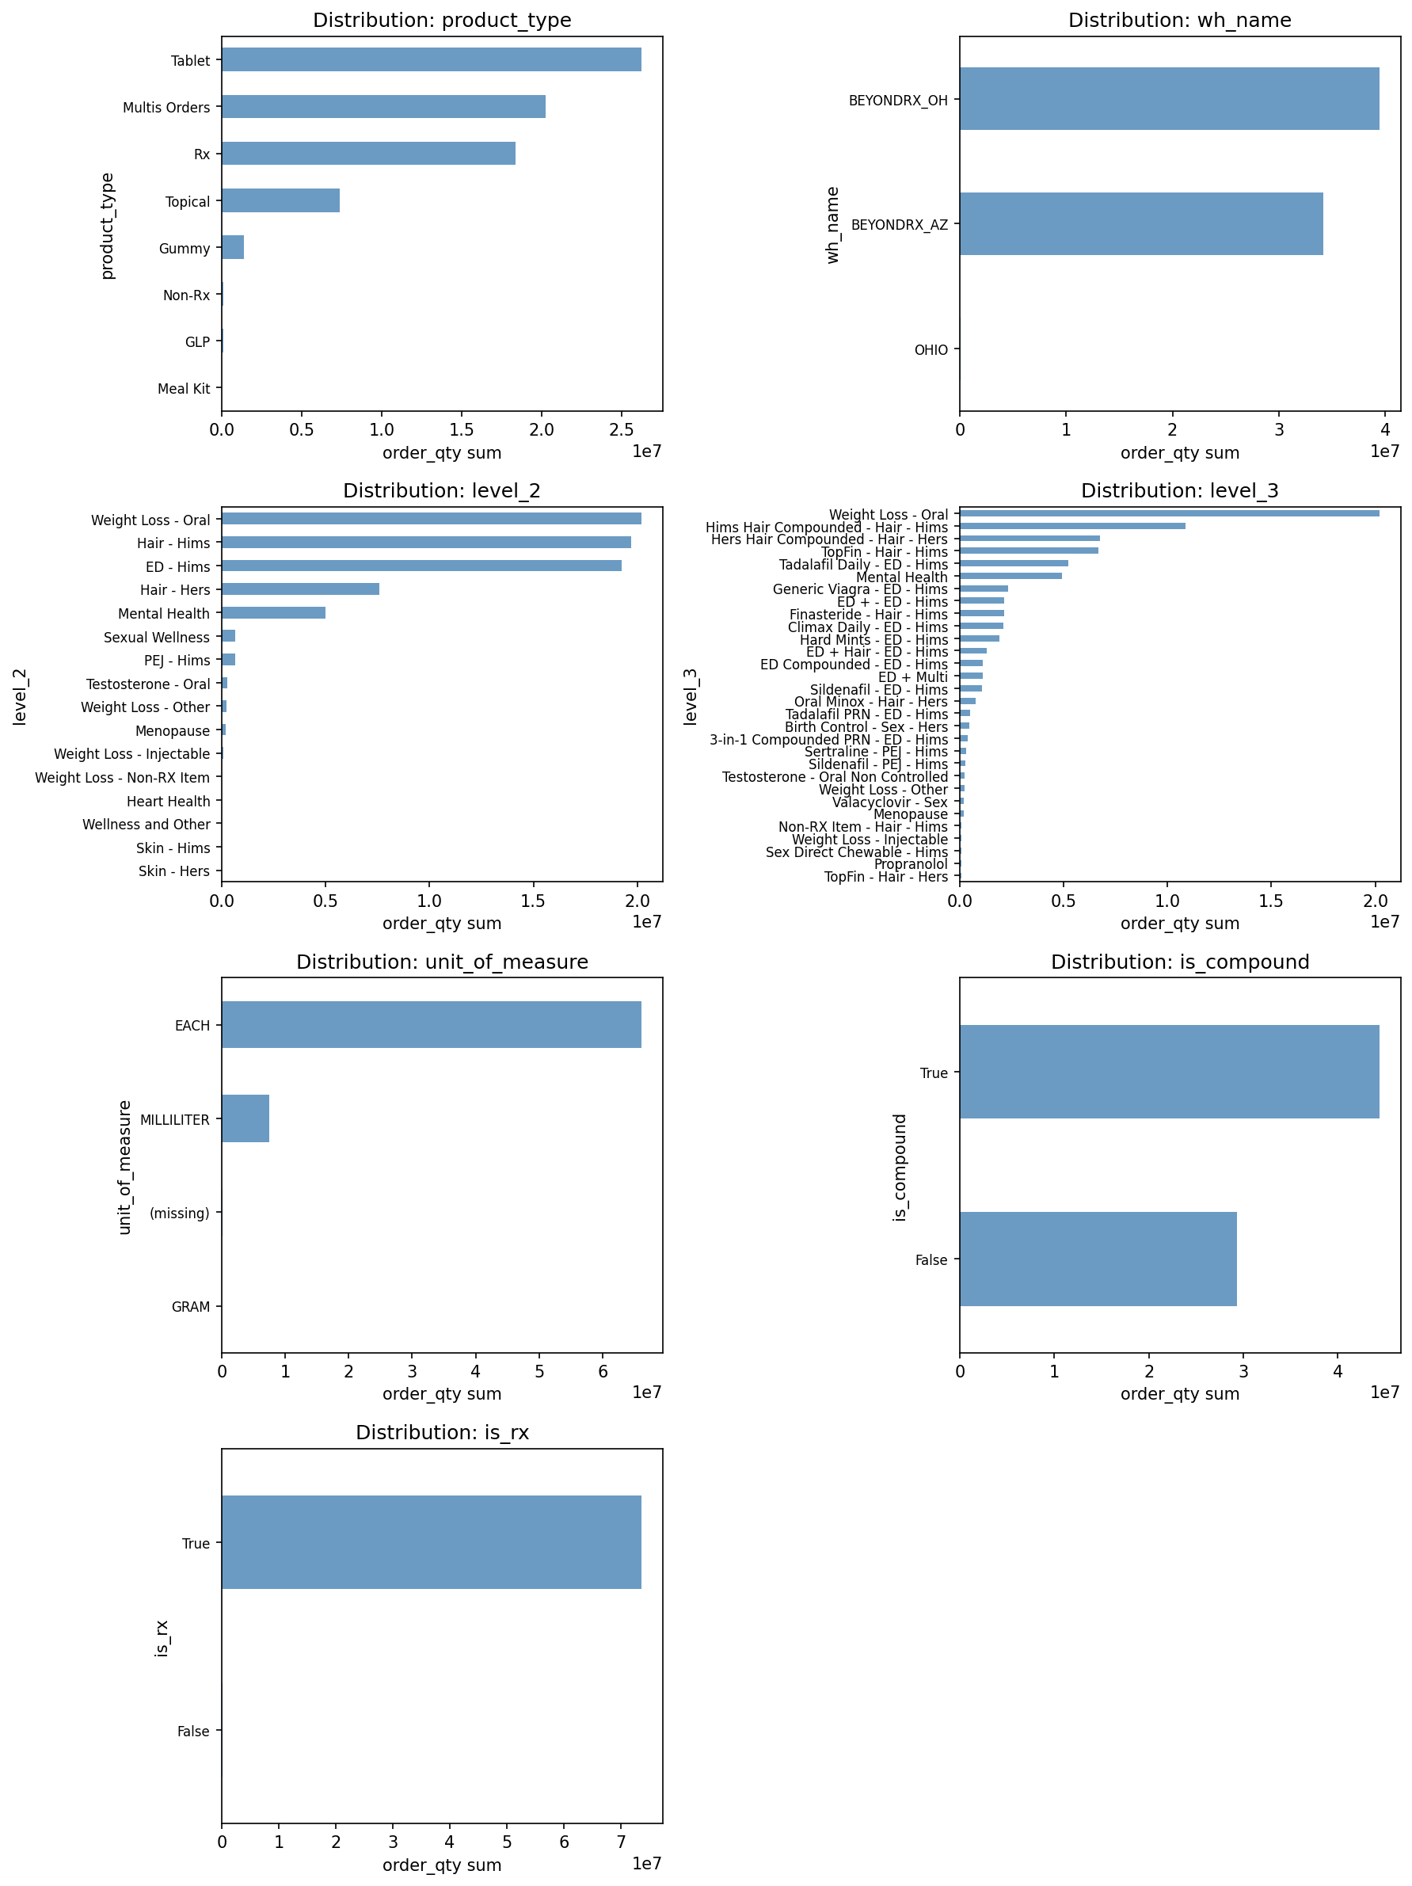

Association Strength
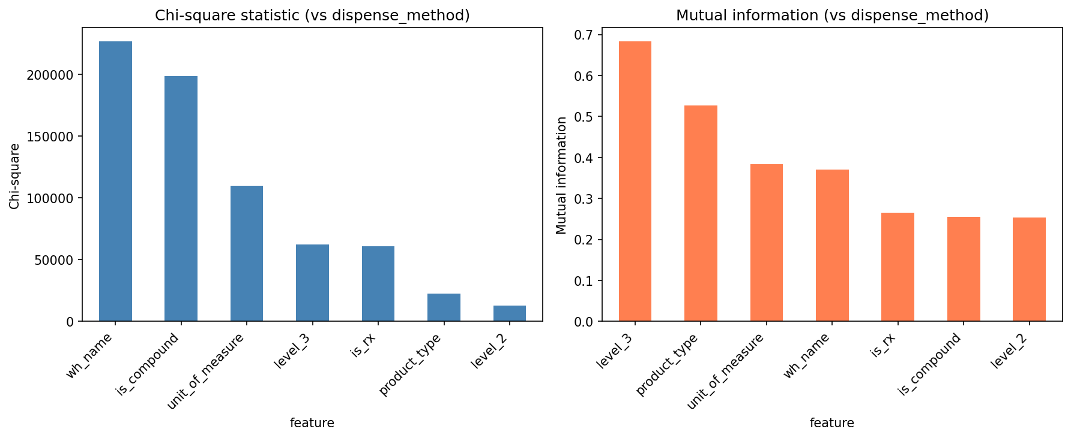

Is Compound vs Dispense Method
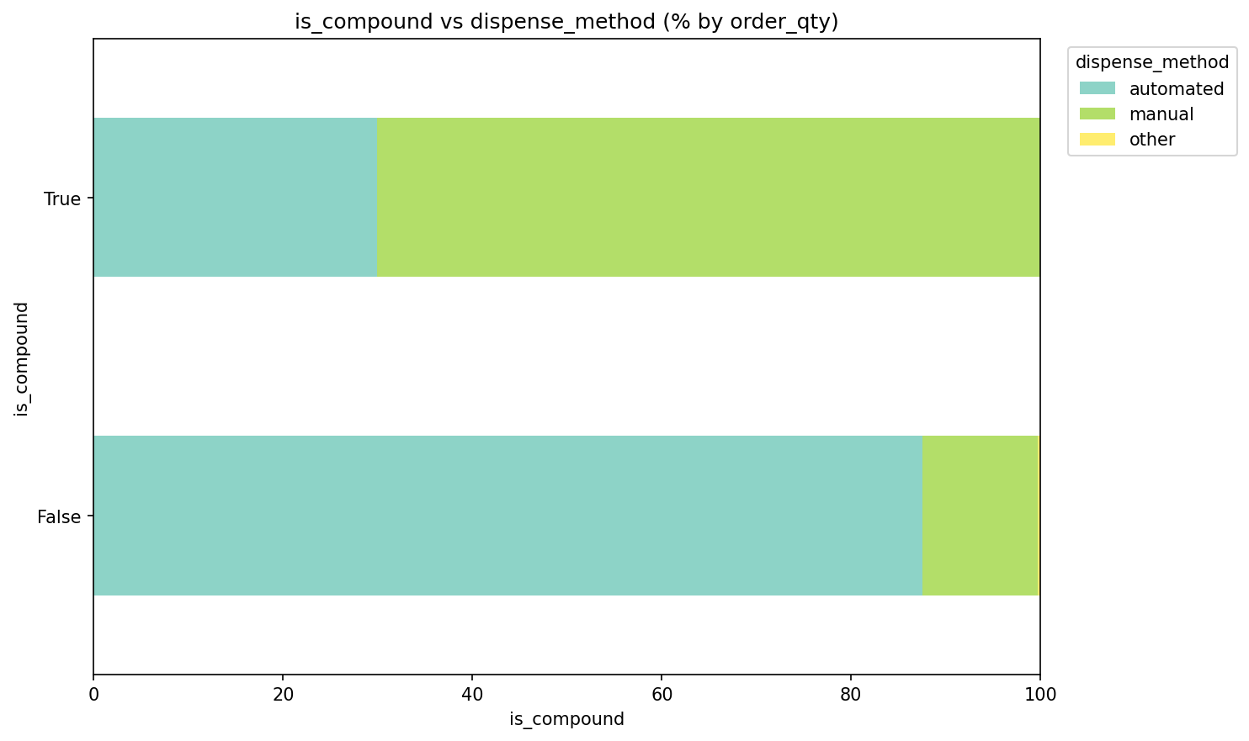
Is Compound distribution by dispense_method

Is Rx vs Dispense Method
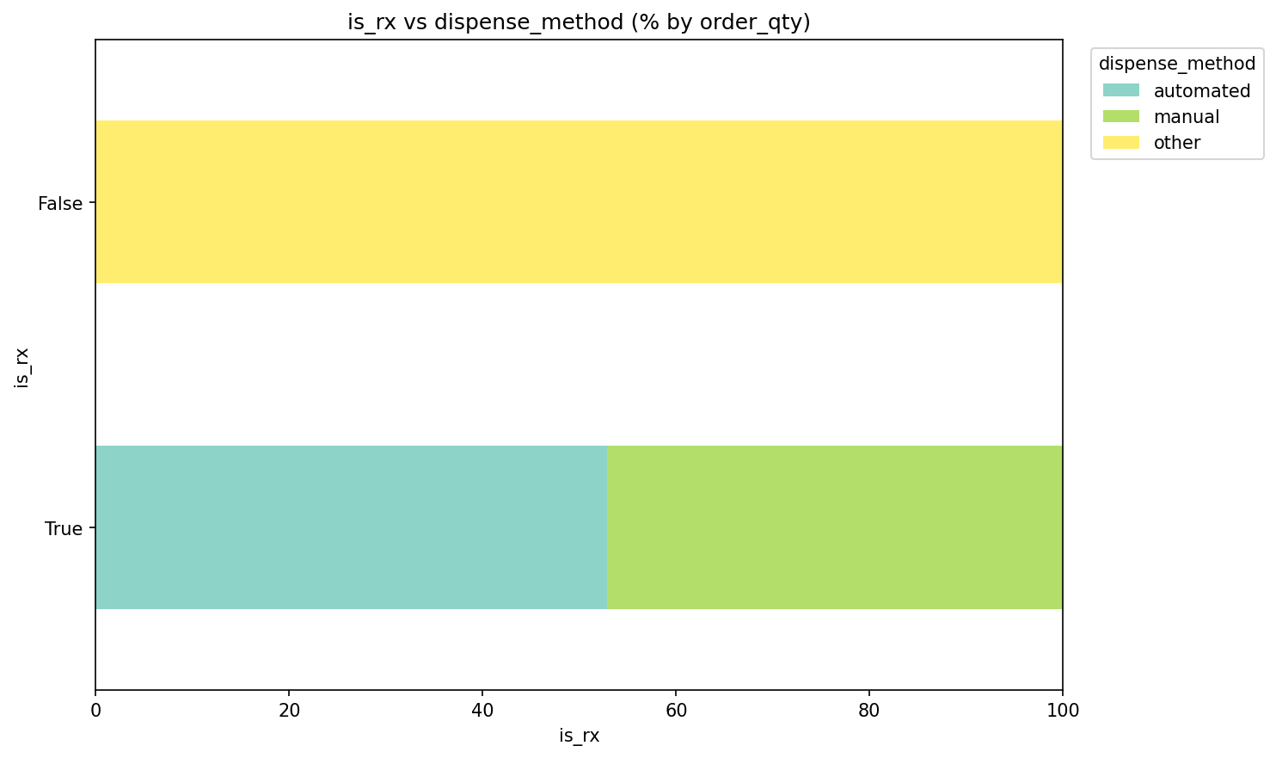
Is Rx distribution by dispense_method

Level 2 vs Dispense Method
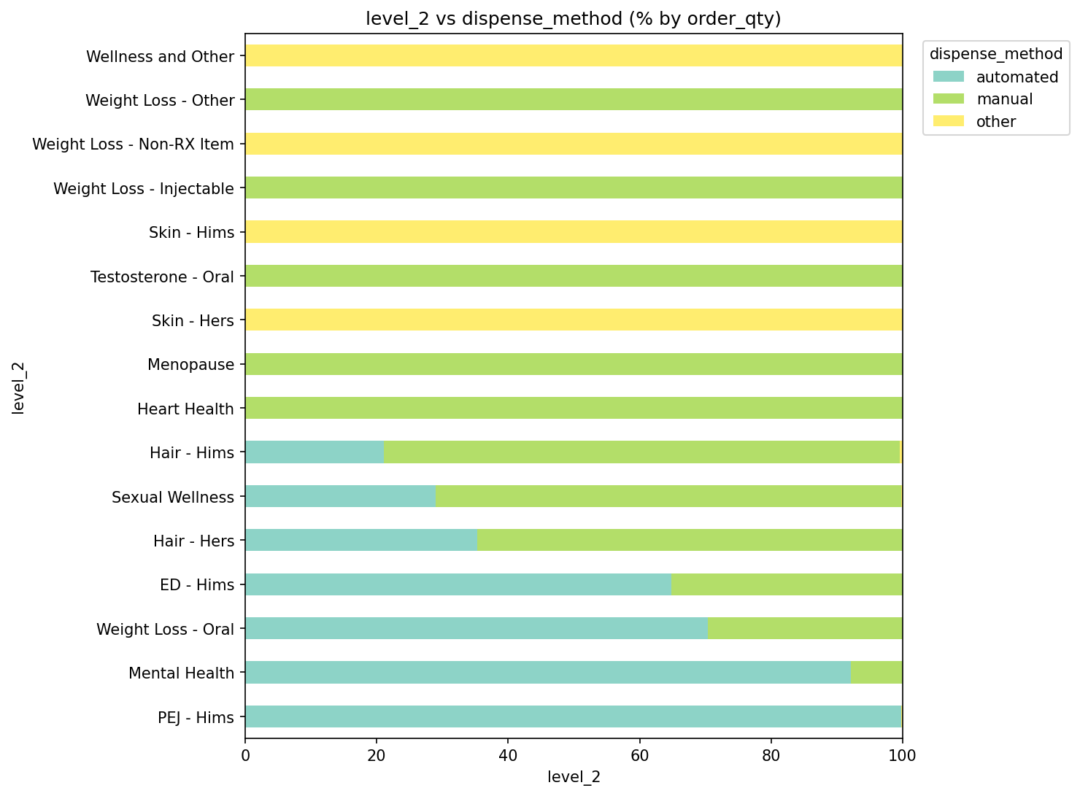
Level 2 distribution by dispense_method

Level 3 vs Dispense Method
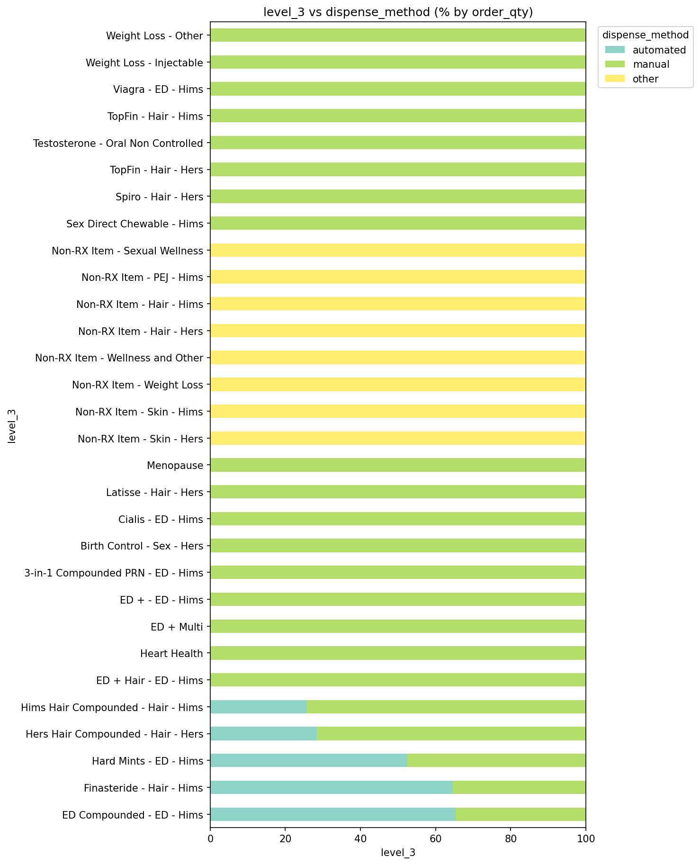
Level 3 distribution by dispense_method

Product Type vs Dispense Method
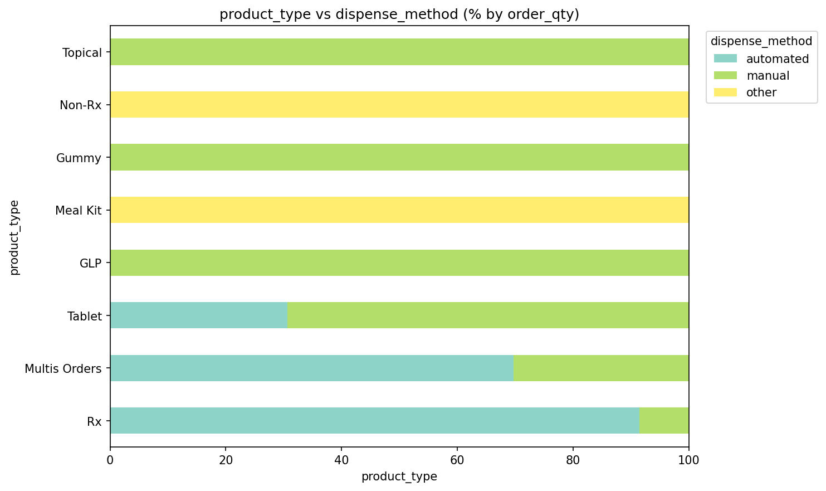
Product Type distribution by dispense_method

Unit Of Measure vs Dispense Method
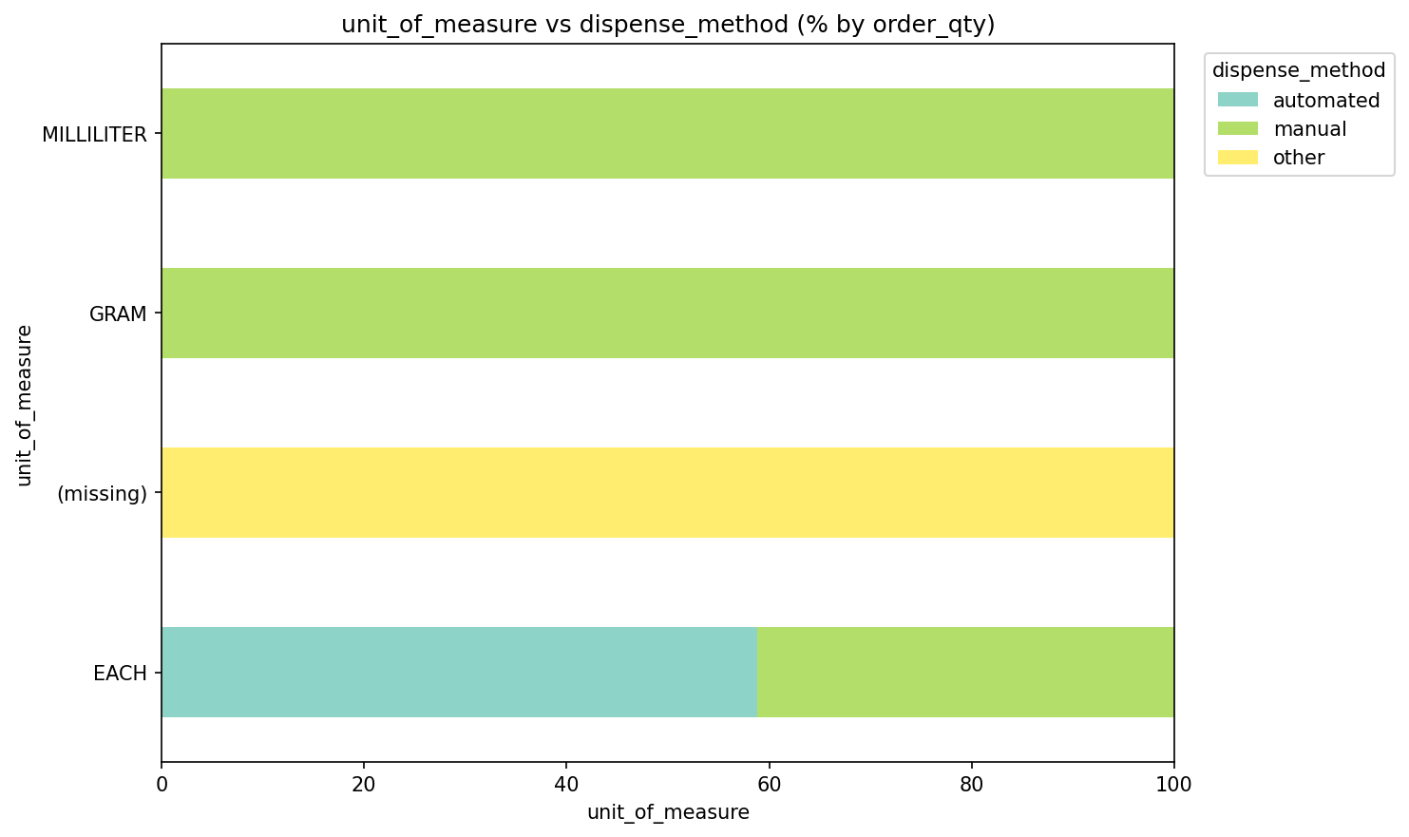
Unit Of Measure distribution by dispense_method

Wh Name vs Dispense Method
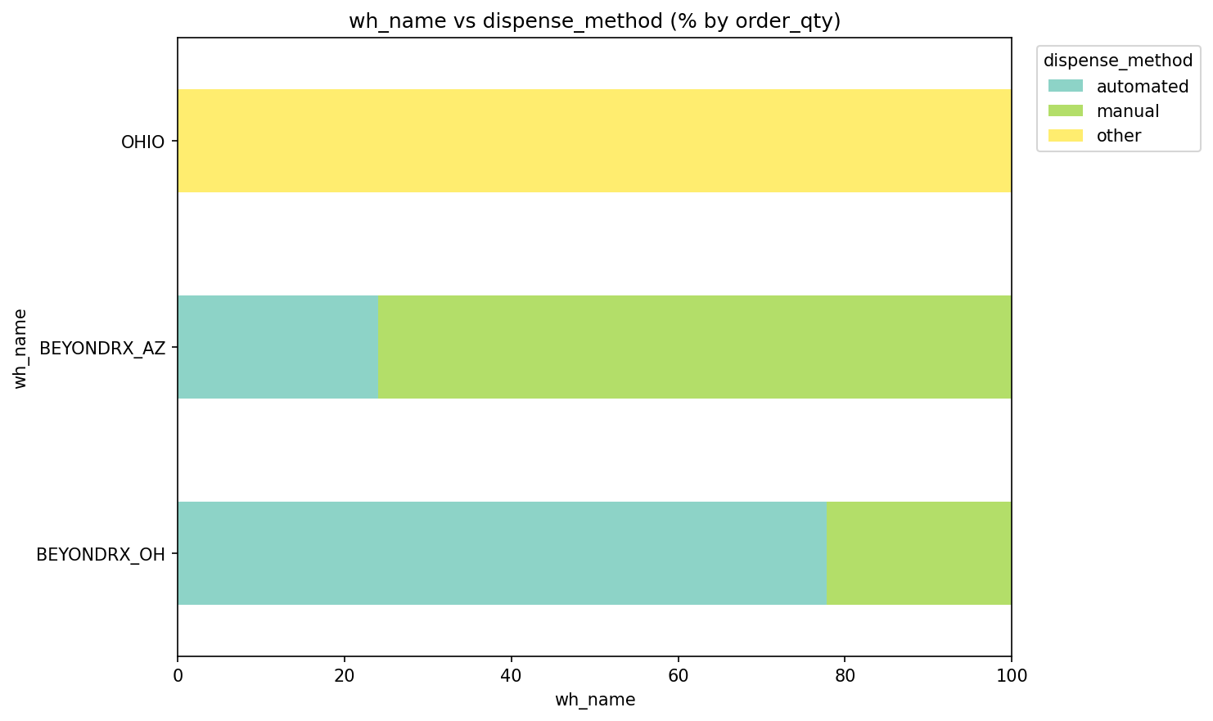
Wh Name distribution by dispense_method

2. Summary Statistics

Overall Dispense Method Summary
cut_dimension | dispense_method | fill_count | order_qty_sum | pct_of_total_fills | pct_of_total_order_qty
Overall | automated | 389265 | 38950899 | 57.07 | 52.81
Overall | manual | 292804 | 34707921 | 42.93 | 47.06
Overall | other | 0 | 95431 | 0.0 | 0.13

Summary by Product Type and Dispense Method
dimension | product_type | dispense_method | fill_count | order_qty_sum
product_type | GLP | manual | 9105 | 75970
product_type | Gummy | manual | 9940 | 1398420
product_type | Meal Kit | other | 0 | 3159
product_type | Multis Orders | automated | 58129 | 14114597
product_type | Multis Orders | manual | 36000 | 6125620
product_type | Non-Rx | other | 0 | 78717
product_type | Rx | automated | 261627 | 16786462
product_type | Rx | manual | 18830 | 1541224
product_type | Rx | other | 0 | 13555
product_type | Tablet | automated | 69509 | 8049840
product_type | Tablet | manual | 173924 | 18196947
product_type | Topical | manual | 45005 | 7369740

3. Distribution Analysis

Distribution by Product Type
dimension | product_type | dispense_method | fill_count | order_qty_sum | pct_within_product_type_by_fills | pct_within_product_type_by_order_qty
product_type | GLP | manual | 9105 | 75970 | 100.0 | 100.0
product_type | Gummy | manual | 9940 | 1398420 | 100.0 | 100.0
product_type | Meal Kit | other | 0 | 3159 |  | 100.0
product_type | Multis Orders | automated | 58129 | 14114597 | 61.75 | 69.74
product_type | Multis Orders | manual | 36000 | 6125620 | 38.25 | 30.26
product_type | Non-Rx | other | 0 | 78717 |  | 100.0
product_type | Rx | automated | 261627 | 16786462 | 93.29 | 91.52
product_type | Rx | manual | 18830 | 1541224 | 6.71 | 8.4
product_type | Rx | other | 0 | 13555 | 0.0 | 0.07
product_type | Tablet | automated | 69509 | 8049840 | 28.55 | 30.67
product_type | Tablet | manual | 173924 | 18196947 | 71.45 | 69.33
product_type | Topical | manual | 45005 | 7369740 | 100.0 | 100.0

Distribution by Warehouse (wh_name)
wh_name | dispense_method | fill_count | order_qty_sum | pct_within_wh_by_fills | pct_within_wh_by_order_qty
BEYONDRX_AZ | automated | 99510 | 8224605 | 32.04 | 24.05
BEYONDRX_AZ | manual | 211113 | 25962028 | 67.96 | 75.93
BEYONDRX_AZ | other | 0 | 5181 | 0.0 | 0.02
BEYONDRX_OH | automated | 289755 | 30726294 | 78.01 | 77.83
BEYONDRX_OH | manual | 81691 | 8745893 | 21.99 | 22.15
BEYONDRX_OH | other | 0 | 8374 | 0.0 | 0.02
OHIO | other | 0 | 81876 |  | 100.0

4. Dispense Ratio Lookup (Apply to Forecast Volume)
Historical ratios from prior 6 months. Use to allocate forecast volume across dispense methods. Level 1 = product_type × wh_name (preferred); fall back to level 2 (product_type), 3 (wh_name), or 4 (overall) if no match.
Formula: estimated_dispense_volume = forecast_volume × (pct_of_volume / 100)
level | product_type | wh_name | dispense_method | pct_of_volume | fill_count | order_qty_sum
1 | GLP | BEYONDRX_AZ | manual | 100.0 | 140 | 1260
1 | GLP | BEYONDRX_OH | manual | 100.0 | 8965 | 74710
1 | Gummy | BEYONDRX_OH | manual | 100.0 | 9940 | 1398420
1 | Meal Kit | OHIO | other | 100.0 | 0 | 3159
1 | Multis Orders | BEYONDRX_AZ | automated | 34.9 | 10158 | 2825881
1 | Multis Orders | BEYONDRX_AZ | manual | 65.1 | 26980 | 5270500
1 | Multis Orders | BEYONDRX_OH | automated | 92.96 | 47971 | 11288716
1 | Multis Orders | BEYONDRX_OH | manual | 7.04 | 9020 | 855120
1 | Non-Rx | OHIO | other | 100.0 | 0 | 78717
1 | Rx | BEYONDRX_AZ | automated | 83.67 | 89350 | 5398634
1 | Rx | BEYONDRX_AZ | manual | 16.25 | 12228 | 1048625
1 | Rx | BEYONDRX_AZ | other | 0.08 | 0 | 5181
1 | Rx | BEYONDRX_OH | automated | 95.79 | 172277 | 11387828
1 | Rx | BEYONDRX_OH | manual | 4.14 | 6602 | 492599
1 | Rx | BEYONDRX_OH | other | 0.07 | 0 | 8374
1 | Tablet | BEYONDRX_AZ | automated | 0.0 | 2 | 90
1 | Tablet | BEYONDRX_AZ | manual | 100.0 | 147299 | 15608923
1 | Tablet | BEYONDRX_OH | automated | 75.67 | 69507 | 8049750
1 | Tablet | BEYONDRX_OH | manual | 24.33 | 26625 | 2588024
1 | Topical | BEYONDRX_AZ | manual | 100.0 | 24466 | 4032720
1 | Topical | BEYONDRX_OH | manual | 100.0 | 20539 | 3337020
2 | GLP | (all) | manual | 100.0 | 9105 | 75970
2 | Gummy | (all) | manual | 100.0 | 9940 | 1398420
2 | Meal Kit | (all) | other | 100.0 | 0 | 3159
2 | Multis Orders | (all) | automated | 69.74 | 58129 | 14114597
2 | Multis Orders | (all) | manual | 30.26 | 36000 | 6125620
2 | Non-Rx | (all) | other | 100.0 | 0 | 78717
2 | Rx | (all) | automated | 91.52 | 261627 | 16786462
2 | Rx | (all) | manual | 8.4 | 18830 | 1541224
2 | Rx | (all) | other | 0.07 | 0 | 13555
2 | Tablet | (all) | automated | 30.67 | 69509 | 8049840
2 | Tablet | (all) | manual | 69.33 | 173924 | 18196947
2 | Topical | (all) | manual | 100.0 | 45005 | 7369740
3 | (all) | BEYONDRX_AZ | automated | 24.05 | 99510 | 8224605
3 | (all) | BEYONDRX_AZ | manual | 75.93 | 211113 | 25962028
3 | (all) | BEYONDRX_AZ | other | 0.02 | 0 | 5181
3 | (all) | BEYONDRX_OH | automated | 77.83 | 289755 | 30726294
3 | (all) | BEYONDRX_OH | manual | 22.15 | 81691 | 8745893
3 | (all) | BEYONDRX_OH | other | 0.02 | 0 | 8374
3 | (all) | OHIO | other | 100.0 | 0 | 81876
4 | (all) | (all) | automated | 52.81 | 389265 | 38950899
4 | (all) | (all) | manual | 47.06 | 292804 | 34707921
4 | (all) | (all) | other | 0.13 | 0 | 95431

See RATIO_APPLICATION.md for full usage.

5. Next Steps
• Apply dispense_ratio_lookup.csv to forecast volume (product_type × wh_name)
• Refresh ratios monthly/quarterly by re-running the analysis pipeline
• Use level 1 ratios first; fall back to level 2/3/4 when forecast lacks dimensions

